**Practical No. 16**

**Develop a simple application to Update, Delete table data from database.**

* **INSERTING INTO THE TABLE:**

**Code:**

*<?php*

*$hn="localhost";*

*$un="root";*

*$pw="";*

*$db="WBP";*

*$conn=new mysqli($hn,$un,$pw,$db);*

*if($conn->connect_error)die($conn->connect_error);*

*$query="INSERT INTO stud(Roll_No,Name,Percent)VALUES(19817,'Aqsa',82.92)";*

*$result=$conn->query($query);*

*if(!$result)*

*{*

*die("Database access failed ".$conn->error);*

*}*

*else*

*{*

*echo "Success!";*

*}*

*?>*

**Output:**

**Before Insertion:**

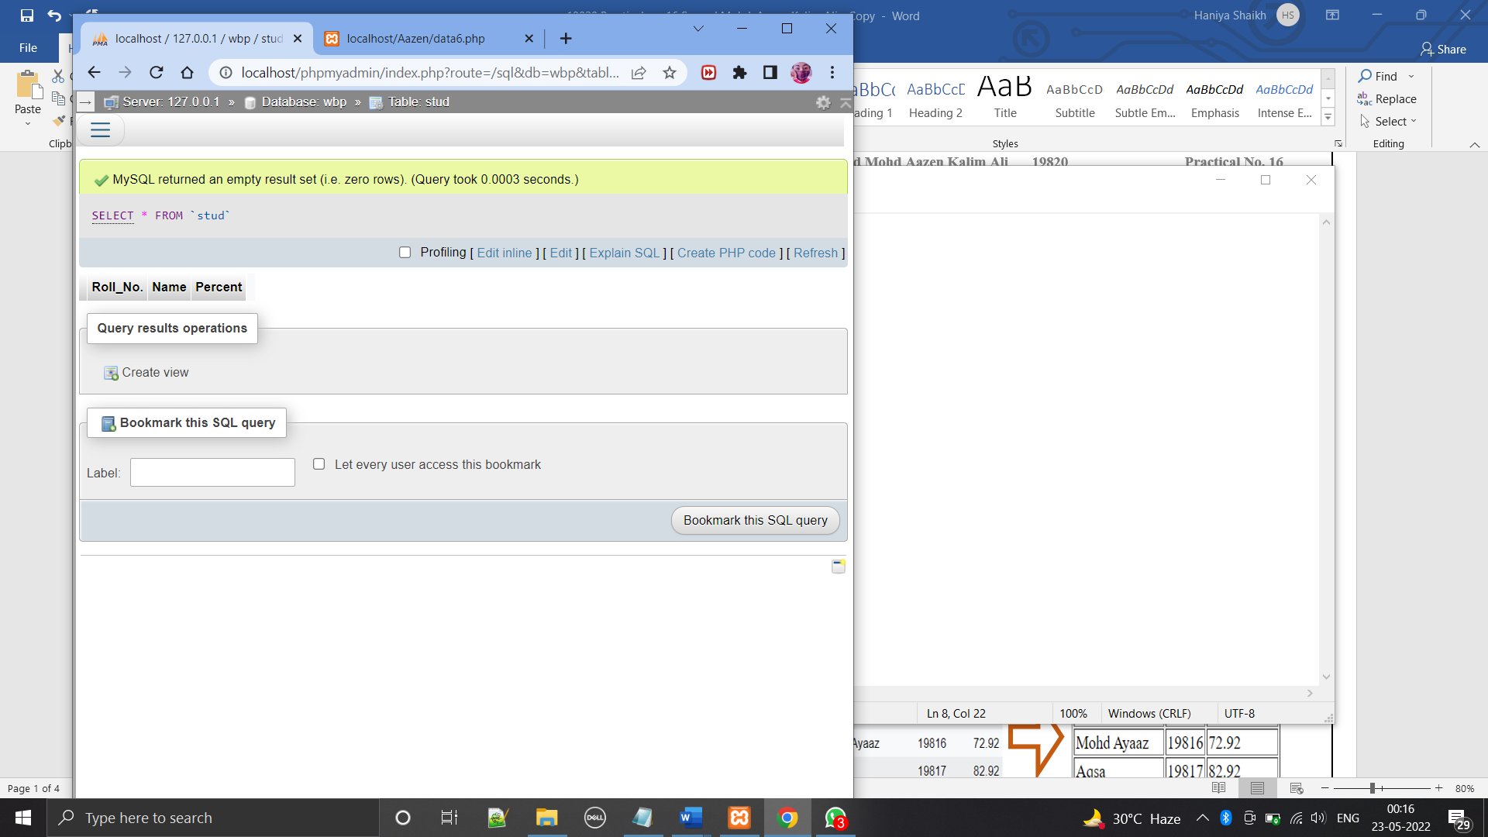

**After Insertion:**

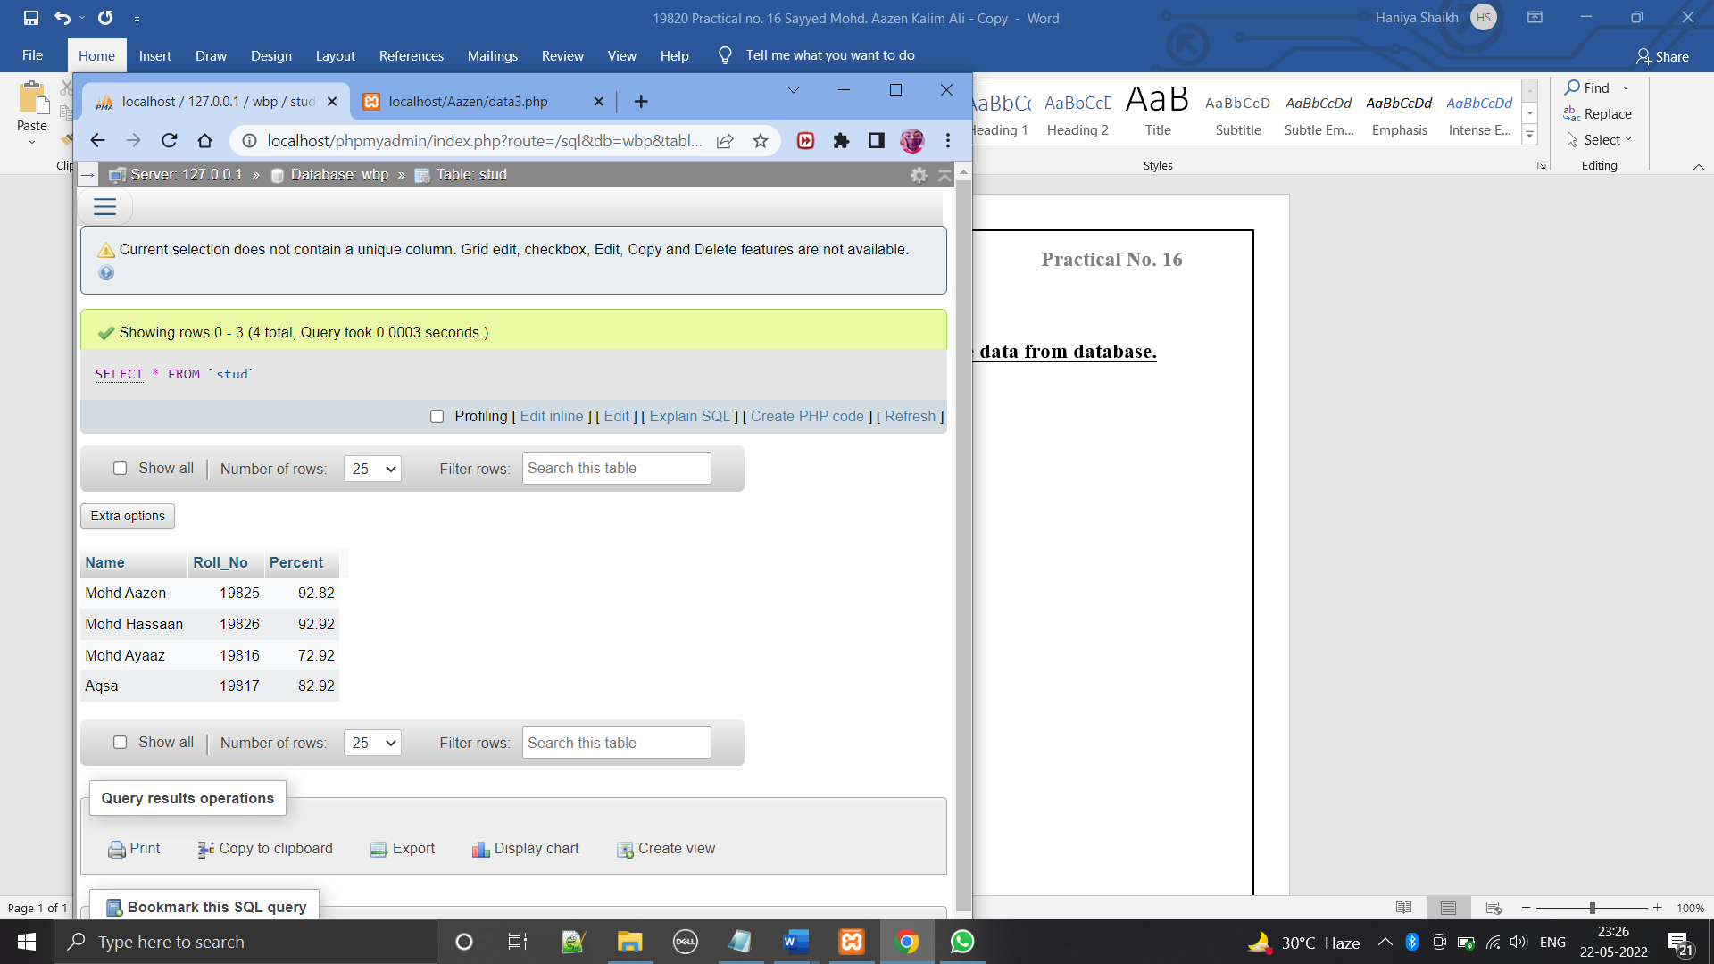

* **RETRIEVING FROM THE TABLE:**

**Code:**

*<?php*

*$hn="localhost";*

*$un="root";*

*$pw="";*

*$db="WBP";*

*$conn=new mysqli($hn,$un,$pw,$db);*

*if($conn->connect_error)die($conn->connect_error);*

*$query="SELECT * FROM stud";*

*$result=$conn->query($query);*

*if(!$result)die("Database access failed ".$conn->error);*

*$rows=$result->num_rows;*

*echo"<table border='1'><tr><th>Roll No.</th><th>Name</th><th>Percentage</th></tr>";*

*for($j=0;$j<$rows;++$j)*

*{*

*$result->data_seek($j);*

*$row=$result->fetch_array(MYSQLI_NUM);*

*echo "<tr>";*

*for($k=0;$k<3;++$k)echo"<td>$row[$k]</td>";*

*echo"</tr>";*

*}*

*echo"</table>";*

*?>***Output:**

 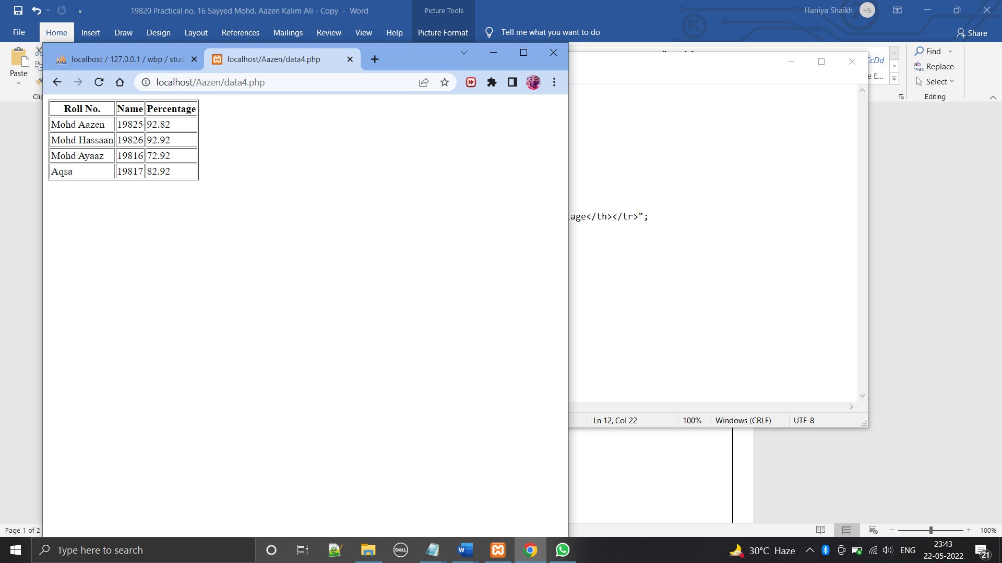

* **UPDATING THE TABLE:**

**Code:**

*<?php*

*$hn="localhost";*

*$un="root";*

*$pw="";*

*$db="WBP";*

*$conn=new mysqli($hn,$un,$pw,$db);*

*if($conn->connect_error)die($conn->connect_error);*

*$query="UPDATE stud SET Roll_No=19820 WHERE Roll_No=19825";*

*$result=$conn->query($query);*

*if(!$result)die("Database access failed ".$conn->error);  
?>*

**Output:**

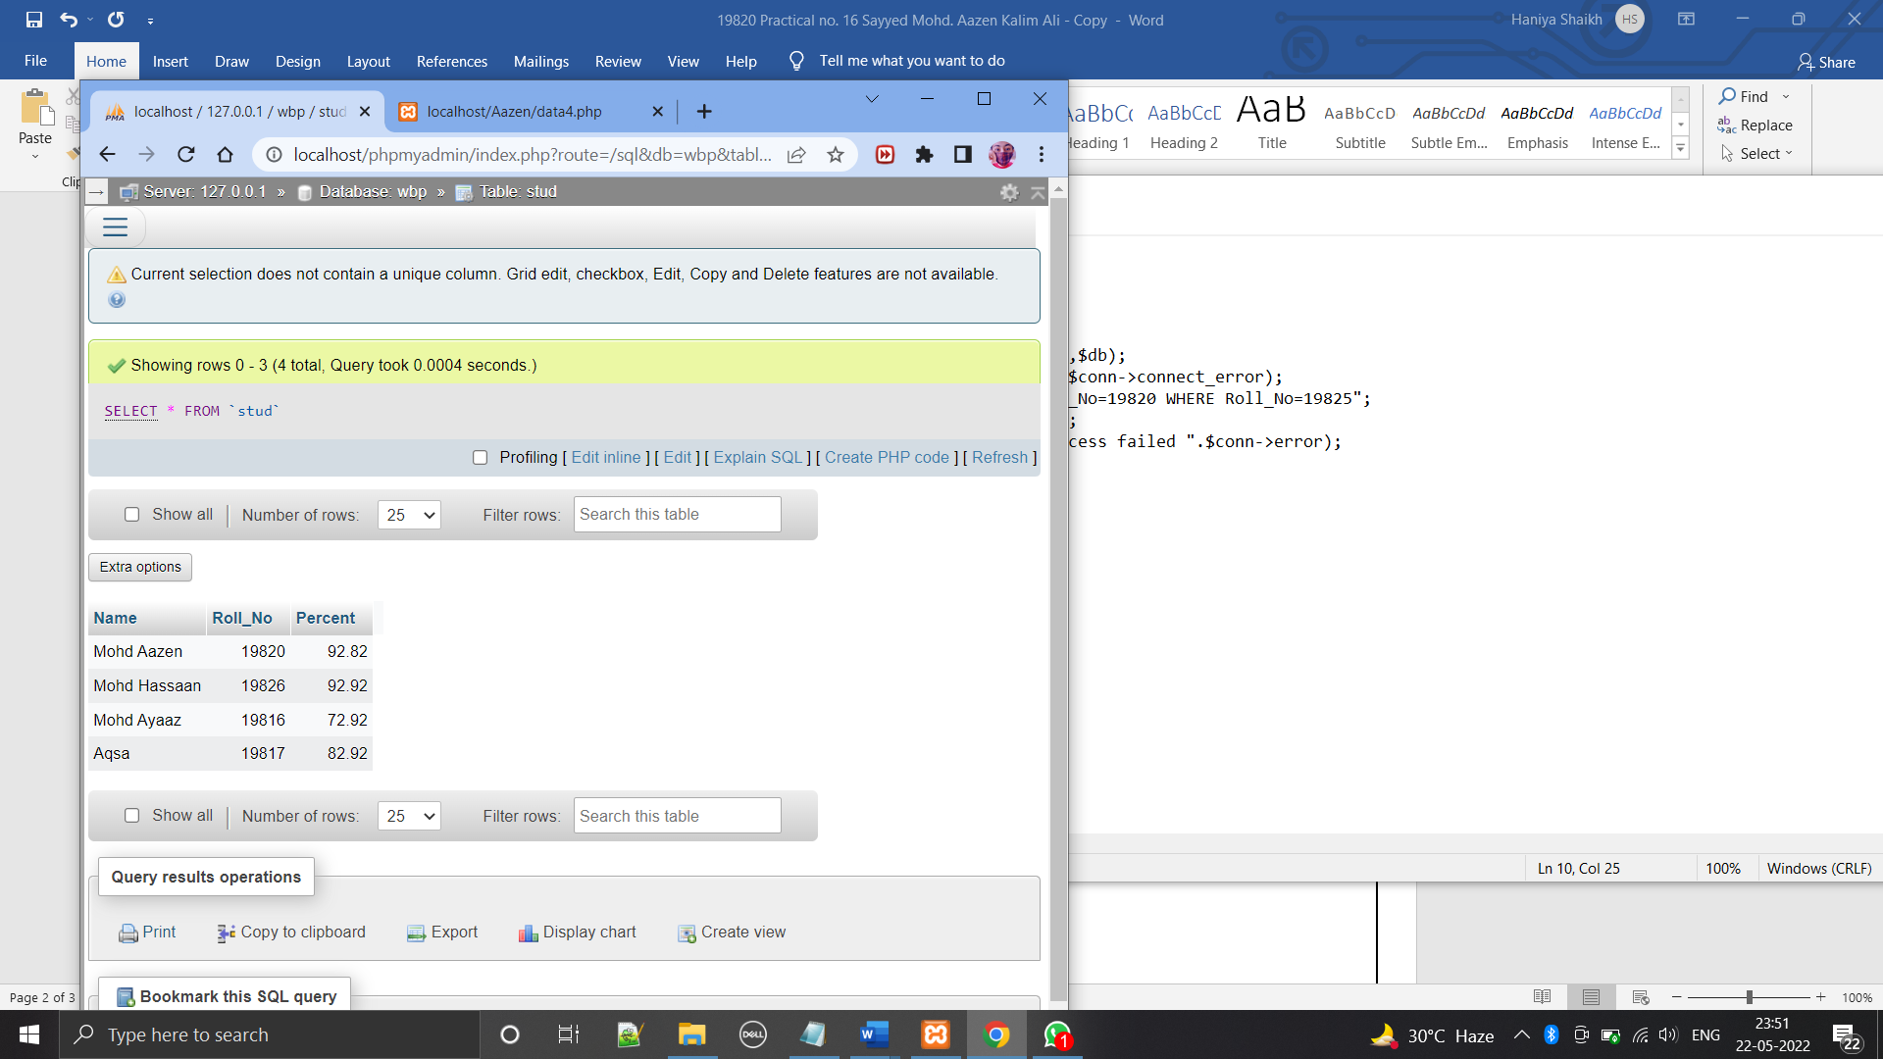

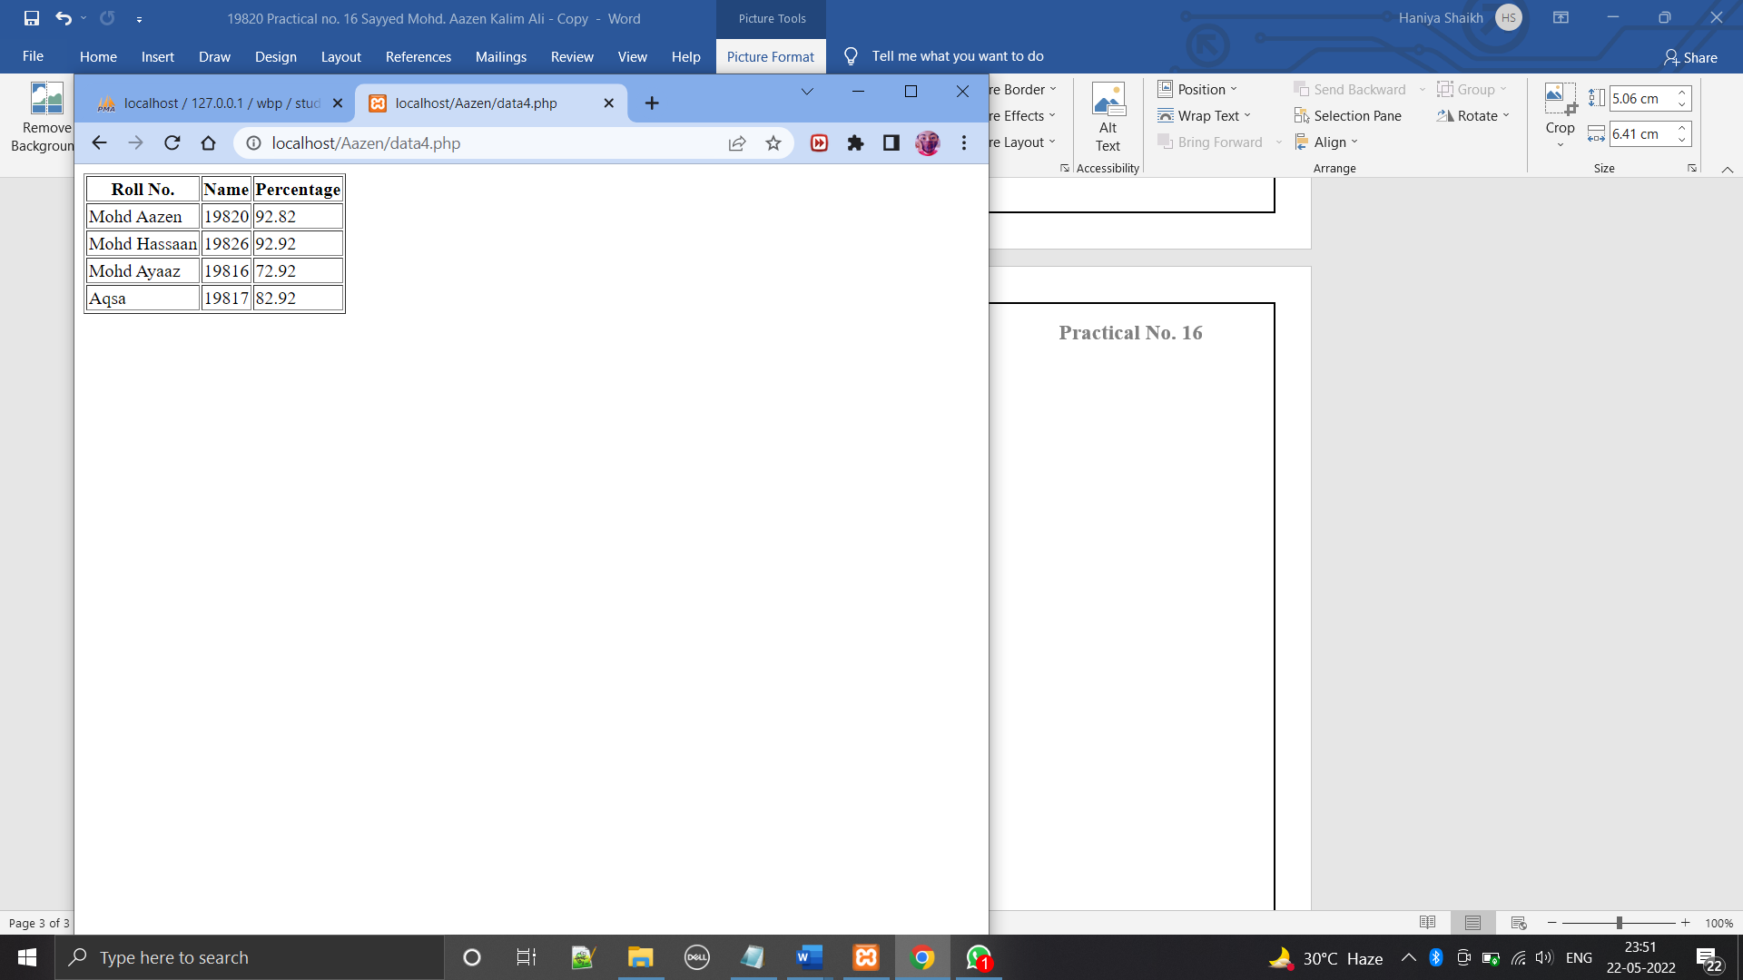

* **DELETING FORM THE TABLE:**

**Code:**

*<?php*

*$hn="localhost";*

*$un="root";*

*$pw="";*

*$db="WBP";*

*$conn=new mysqli($hn,$un,$pw,$db);*

*if($conn->connect_error)die($conn->connect_error);*

*$query="DELETE FROM stud WHERE Roll_No=19826";*

*$result=$conn->query($query);*

*if(!$result)die("Database access failed ".$conn->error);*

*?>***Output:**

**Before Deletion: After Deletion:**

 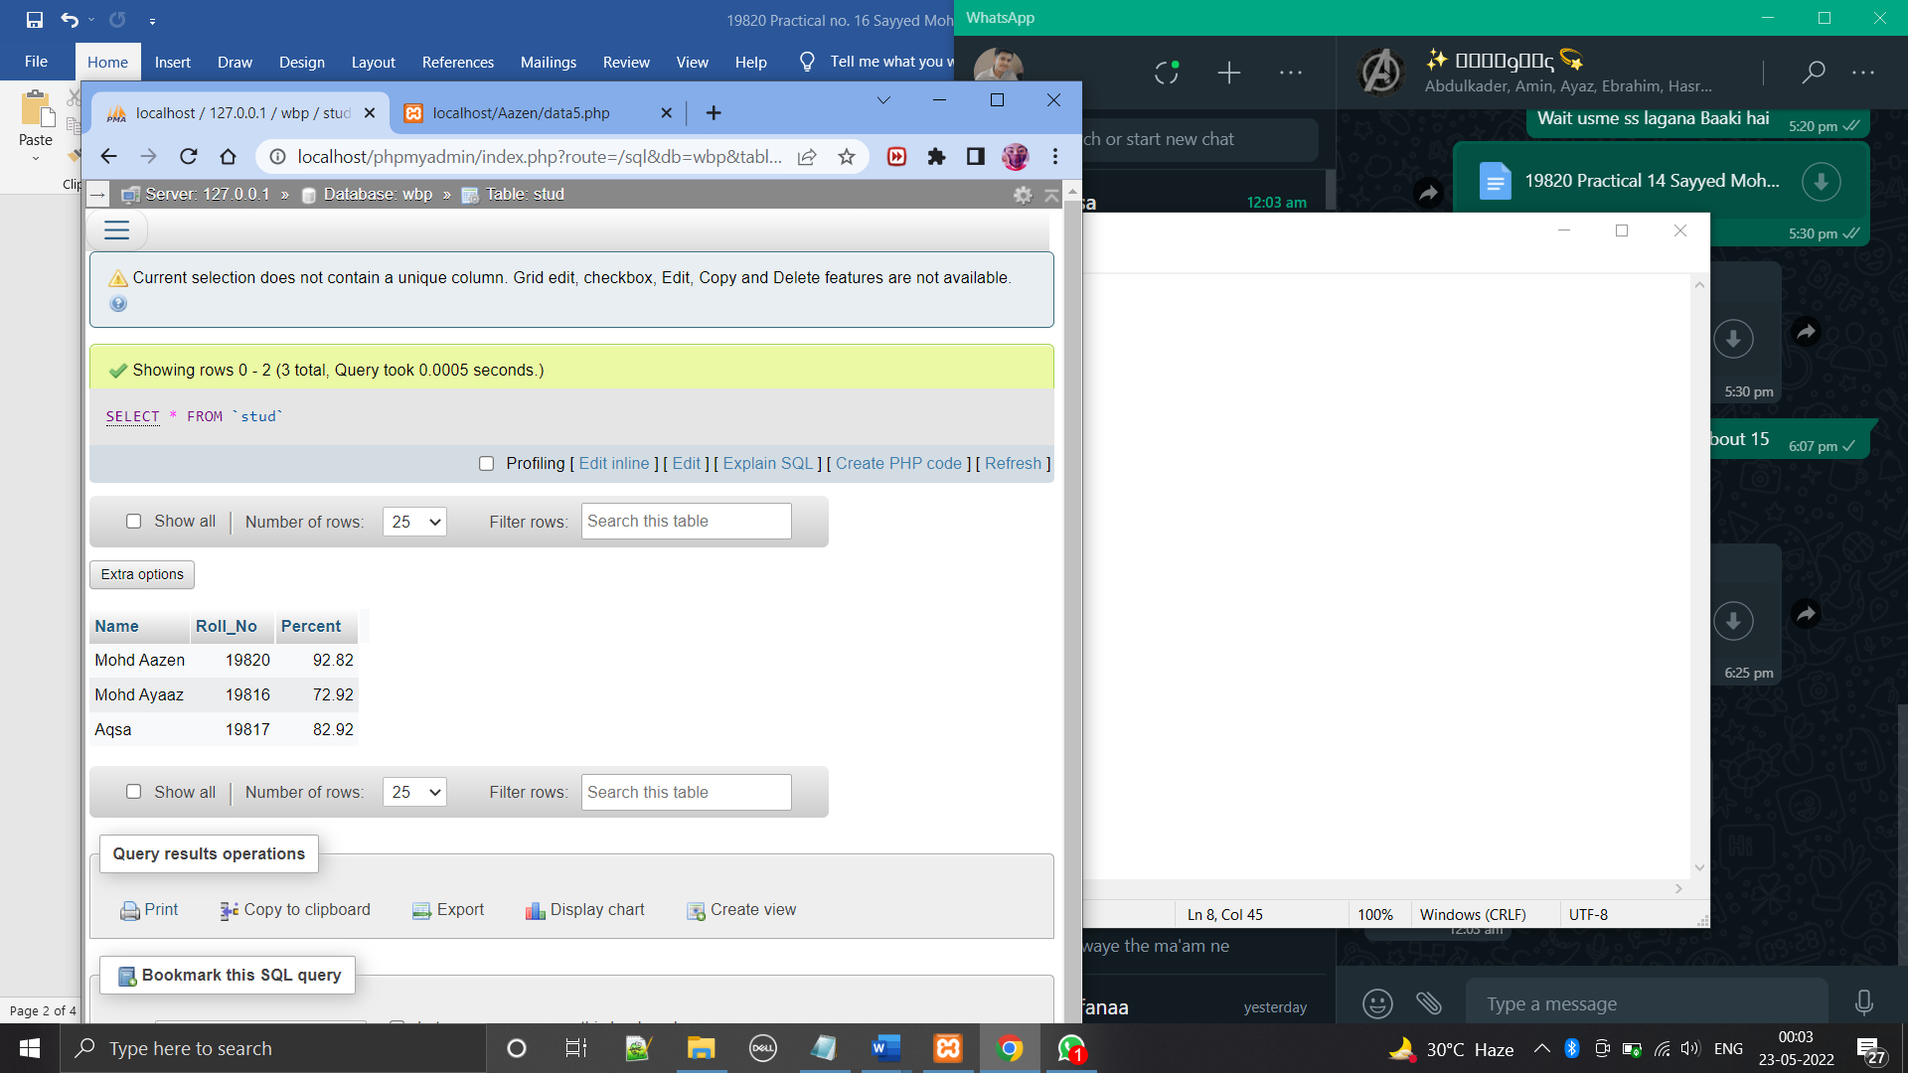

**THANK YOU!!!**